**DAA Assignment -1**

**- 21071A6789**

1 .Given a row wise sorted matrix of size **R*C** where R and C are always **odd**, find the

median of the matrix. **5Marks**

**Test Case 1:**

**Input**:

R = 3, C = 3

M = [[1, 3, 5],

[2, 6, 9],

[3, 6, 9]]

**Output:** 5

**Explanation**: Sorting matrix elements gives us {1,2,3,3,5,6,6,9,9}. Hence, 5 is median.

**Test Case 2:**

**Input:**

R = 3, C = 1

M = [[1], [2], [3]]

**Output:** 2

**Explanation**: Sorting matrix elements gives us {1,2,3}. Hence, 2 is median.

➢ **Constraints:**

1 <= R, C <= 400

1 <= matrix[i][j] <= 2000

**Code(python):**

r=int(input('Enter number of rows: ')) c=int(input('Enter number of columns: ')) m=[]

print('Enter matrix elements: ')

for i in range(r):

a=list(map(int,input().split()))

m.append(a)

import numpy median=numpy.median(m)

print(f'Median is: {median}')

**Outputs**

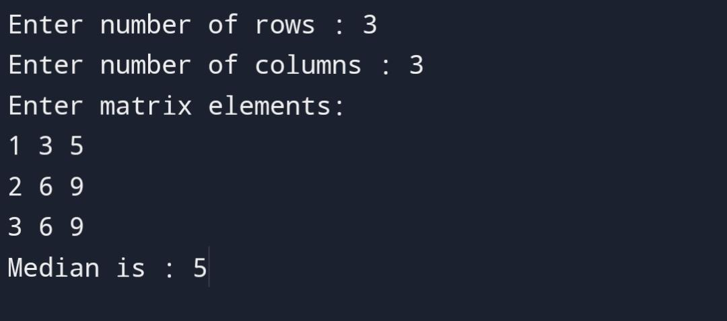

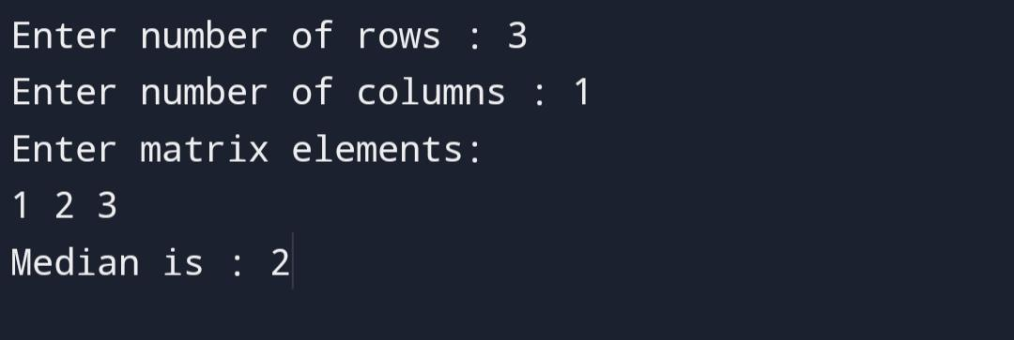

2. Given the arrival and departure times of all trains that reach a railway station, the task is to find the minimum number of platforms required for the railway station so that no train waits. We are given two arrays that represent the arrival and departure times of

trains that stop. **5Marks**

**Test case 1**

***Input:*** *arr[] = {9:00, 9:40, 9:50, 11:00, 15:00, 18:00}, dep[] = {9:10, 12:00, 11:20, 11:30,*

*19:00, 20:00}*

# Output: 3

***Explanation:*** *There are at-most three trains at a time (time between 9:40 to 12:00)*

**Test case 2**

***Input:*** *arr[] = {9:00, 9:40}, dep[] = {9:10, 12:00}*

# Output: 1

***Explanation:*** *Only one platform is needed.*

**Code(python):**

arri=list(input('Enter arrival time :').split())

dep=list(input('Enter departure time :').split())

arrival=[] departure=[]

for i in arri

i=list(i)

i.remove(':') j=''.join(i) j=int(j) arrival.append() for i in dep: i=list(i)

i.remove(':') j=''.join(i)

j=int(j) departure.append(j) n=len(arrival) arrival.sort() departure.sort()

p=1

req_p=1 i,j=1,0

while i<n and j<n:

if arrival[i]<=departure [j]:

p+=1 i+=1

else:

p-=1

j+=1

req_p=max(req_p,p)

print(‘ number of platforms : {req_p}')

**Outputs**

